https://wiki.tcsbank.ru/display/SD/m1-pr-onl02@ONLINE+-+Heartbeat

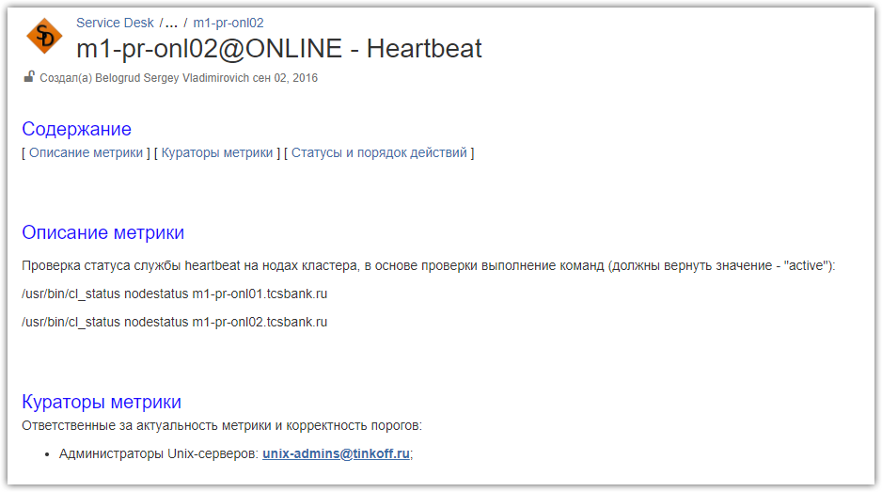

#
# To disable heartbeat service after server was booted in single mode, I’ve moved follow file from start directory.
#
# 1. Step: boot server with “single” parameter in kernel boot string in grub.
# 2. Remove file /etc/rc3.d/S75heartbeat
# 3. Run: init 3
# 4. After all, don’t forget to run chkconfig heartbeat on

[root@m1-pr-onl02 ~]# ls -Alh /etc/rc3.d/*heart*
lrwxrwxrwx 1 root root 19 Jun 17 04:16 /etc/rc3.d/S75heartbeat -> ../init.d/heartbeat
[root@m1-pr-onl02 ~]#

# It’s very old OS version.
[root@m1-pr-onl02 ~]# cat /etc/redhat-release
Red Hat Enterprise Linux Server release 5.5 (Tikanga)
[root@m1-pr-onl02 ~]#

#
# Below are places where to see something about heartbeat state.
#
[root@ds-pr-onl02 ~]# tail -f /var/log/messages | grep -e "heartbeat:"

[root@m1-pr-onl02 ~]# grep -e "heartbeat:" /var/log/messages | head -n 10
Jun 18 04:05:47 m1-pr-onl02 heartbeat: [6859]: info: Daily informational memory statistics
Jun 18 04:05:47 m1-pr-onl02 heartbeat: [6859]: info: MSG stats: 11/139950 ms age 0 [pid6859/MST_CONTROL]
Jun 18 04:05:47 m1-pr-onl02 heartbeat: [6859]: info: cl_malloc stats: 689/4186903 74644/34325 [pid6859/MST_CONTROL]
Jun 18 04:05:47 m1-pr-onl02 heartbeat: [6859]: info: RealMalloc stats: 101516 total malloc bytes. pid [6859/MST_CONTROL]
Jun 18 04:05:47 m1-pr-onl02 heartbeat: [6859]: info: Current arena value: 0
Jun 18 04:05:47 m1-pr-onl02 heartbeat: [6859]: info: MSG stats: 0/1 ms age 86974100 [pid6897/HBFIFO]
Jun 18 04:05:47 m1-pr-onl02 heartbeat: [6859]: info: cl_malloc stats: 297/348 29460/13442 [pid6897/HBFIFO]
Jun 18 04:05:47 m1-pr-onl02 heartbeat: [6859]: info: RealMalloc stats: 30784 total malloc bytes. pid [6897/HBFIFO]
Jun 18 04:05:47 m1-pr-onl02 heartbeat: [6859]: info: Current arena value: 0
Jun 18 04:05:47 m1-pr-onl02 heartbeat: [6859]: info: MSG stats: 0/0 ms age 92093104 [pid6898/HBWRITE]
[root@m1-pr-onl02 ~]#

[root@ds-pr-onl02 ~]# tail /var/log/ha-log
heartbeat[13033]: 2018/06/18_17:26:08 info: Current arena value: 0
heartbeat[13033]: 2018/06/18_17:26:08 info: MSG stats: 0/0 ms age 514170572 [pid13036/HBWRITE]
heartbeat[13033]: 2018/06/18_17:26:08 info: cl_malloc stats: 381/119600 36484/17187 [pid13036/HBWRITE]
heartbeat[13033]: 2018/06/18_17:26:08 info: RealMalloc stats: 45020 total malloc bytes. pid [13036/HBWRITE]
heartbeat[13033]: 2018/06/18_17:26:08 info: Current arena value: 0
heartbeat[13033]: 2018/06/18_17:26:08 info: MSG stats: 0/0 ms age 514170572 [pid13037/HBREAD]
heartbeat[13033]: 2018/06/18_17:26:08 info: cl_malloc stats: 382/165854 36568/17231 [pid13037/HBREAD]
heartbeat[13033]: 2018/06/18_17:26:08 info: RealMalloc stats: 37512 total malloc bytes. pid [13037/HBREAD]
heartbeat[13033]: 2018/06/18_17:26:08 info: Current arena value: 0
heartbeat[13033]: 2018/06/18_17:26:08 info: These are nothing to worry about.
[root@ds-pr-onl02 ~]#

[root@m1-pr-onl02 ~]# head /var/log/ha-debug
heartbeat[6859]: 2018/06/18_04:03:30 debug: APIregistration_dispatch() {
heartbeat[6859]: 2018/06/18_04:03:30 debug: process_registerevent() {
heartbeat[6859]: 2018/06/18_04:03:30 debug: client->gsource = 0x973e908
heartbeat[6859]: 2018/06/18_04:03:30 debug: }/*process_registerevent*/;
heartbeat[6859]: 2018/06/18_04:03:30 debug: }/*APIregistration_dispatch*/;
heartbeat[6859]: 2018/06/18_04:03:30 debug: Checking client authorization for client 4012 (0:104)
heartbeat[6859]: 2018/06/18_04:03:30 debug: create_seq_snapshot_table:no missing packets found for node m1-pr-onl02.tcsbank.ru
heartbeat[6859]: 2018/06/18_04:03:30 debug: create_seq_snapshot_table:no missing packets found for node ds-pr-onl02.tcsbank.ru
heartbeat[6859]: 2018/06/18_04:03:30 debug: Signing on API client 4012 ('casual')
heartbeat[6859]: 2018/06/18_04:03:30 debug: Signing client 4012 off
[root@m1-pr-onl02 ~]#

#
# To see something useful about cluster state.
#
[root@m1-pr-onl02 ~]# cl_status hbstatus
Heartbeat is running on this machine.
[root@m1-pr-onl02 ~]# /usr/bin/cl_status nodestatus ds-pr-onl02.tcsbank.ru
active
[root@m1-pr-onl02 ~]# /usr/bin/cl_status nodestatus m1-pr-onl02.tcsbank.ru
active
[root@m1-pr-onl02 ~]#

[root@m1-pr-onl02 ~]# egrep -v "^#|^$" /etc/ha.d/ha.cf
debugfile /var/log/ha-debug
logfile /var/log/ha-log
logfacility local0
keepalive 2
deadtime 30
udpport 695
ucast bond0.1712 10.217.12.212
auto_failback off
node m1-pr-onl02.tcsbank.ru ds-pr-onl02.tcsbank.ru
debug 1

[root@m1-pr-onl02 ~]#

[root@m1-pr-onl02 ~]# /usr/bin/cl_status listnodes
ds-pr-onl02.tcsbank.ru
m1-pr-onl02.tcsbank.ru
[root@m1-pr-onl02 ~]#

[root@m1-pr-onl02 ~]# /usr/bin/cl_status nodestatus ds-pr-onl02.tcsbank.ru ; /usr/bin/cl_status nodestatus ds-pr-onl02.tcsbank.ru m1-pr-onl02.tcsbank.ru
active
active
[root@m1-pr-onl02 ~]#

# Useless command. I don’t know what to do with this output.
[root@m1-pr-onl02 ~]# /usr/bin/cl_status hblinkstatus ds-pr-onl02.tcsbank.ru bond0.1712
up
[root@m1-pr-onl02 ~]# /usr/bin/cl_status hblinkstatus m1-pr-onl02.tcsbank.ru bond0.1712
dead
[root@m1-pr-onl02 ~]#

# After all.
[root@m1-pr-onl02 ~]# chkconfig heartbeat on
[root@m1-pr-onl02 ~]# chkconfig --list heartbeat
heartbeat 0:off 1:off 2:on 3:on 4:on 5:on 6:off
[root@m1-pr-onl02 ~]#

